Banking Model Representation – 1-Page Summary Report

Problem Statement
A retail bank’s credit team needs to understand and implement the fundamental linear model f_w,b(x) = w·x + b that relates an applicant’s annual income to the maximum loan amount that can be approved. With only two historical credit decisions (Income 1.0 → Loan 300; Income 2.0 → Loan 500, units of $10k), the analyst must (1) represent the model in code, (2) visualize the underwriting relationship, (3) discover parameters that fit the observed decisions, and (4) produce a loan-limit forecast for a new applicant with income = 1.2 units ($12,000).

Solution Strategy
- Define training arrays x_train (applicant income) and y_train (max loan amount) and inspect m, individual examples.
- Scatter-plot the two credit decisions to confirm a linear income–loan relationship.
- Implement compute_model_output both with an explicit loop (pedagogical) and a vectorized NumPy expression (production-ready).
- Experimentally discover the unique parameters w = 200, b = 100 that pass through both observed decisions.
- Predict the loan limit for a new applicant income of 1.2 and quantify sensitivity of the offer to ±10 % changes in w and b (credit-policy levers).
- Add residual checks, a third synthetic applicant, and a multi-line simulation plot for policy intuition.

Solution
The fitted underwriting rule is Max Loan = 200 × Income + 100. For a new applicant with income of 1.2 units ($12,000) the model forecasts a maximum loan of 340 units (≈ $3.4 M if each unit equals $10 k). Residuals on the original data are exactly zero; the vectorized and loop implementations produce identical outputs.
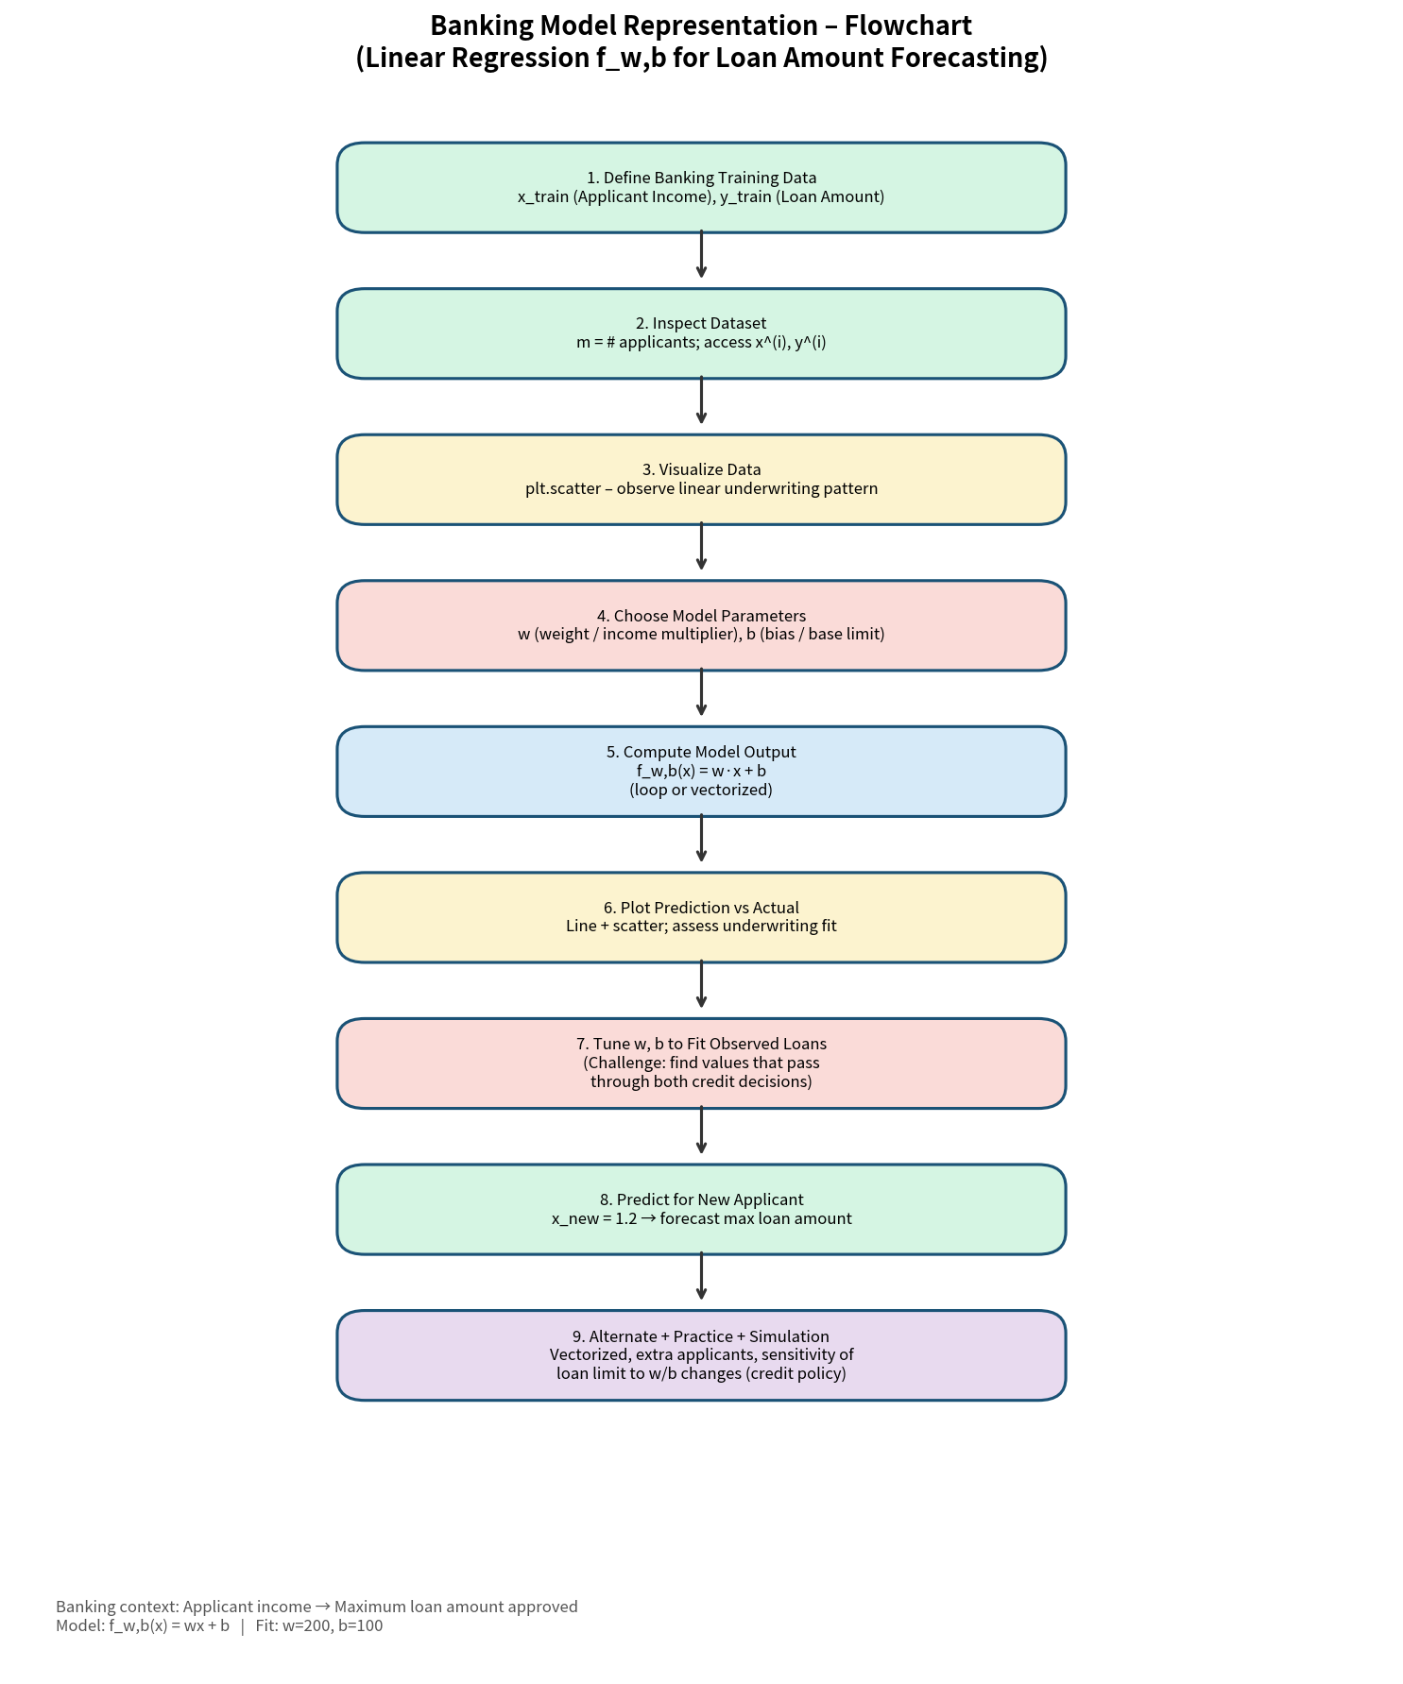
Figure 1 – Workflow flowchart (data → model → fit → forecast → simulation)
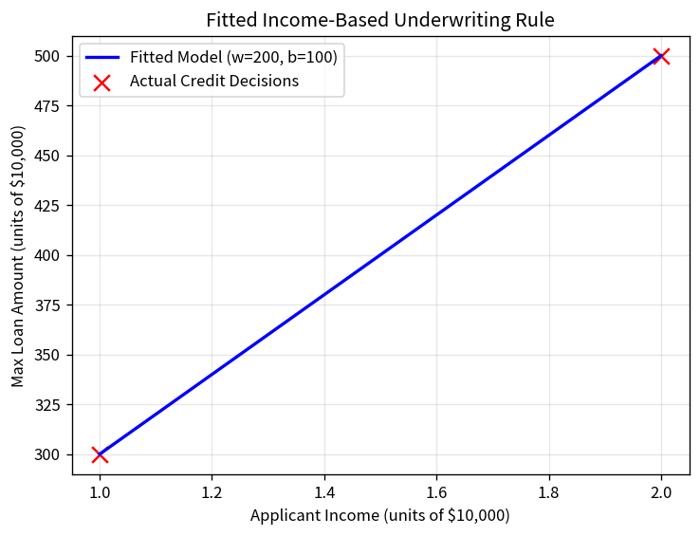
Figure 2 – Fitted income-based underwriting line through the two observed credit decisions
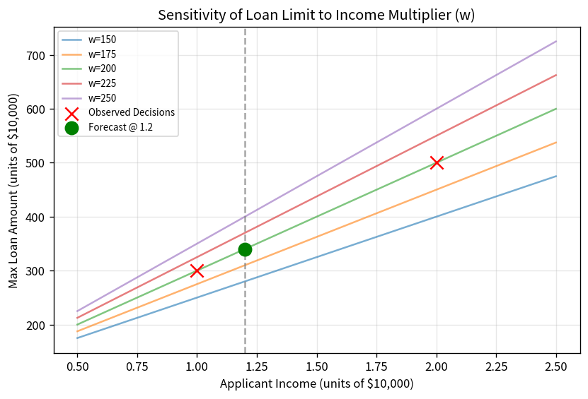
Figure 3 – Sensitivity of the loan limit to alternative income multipliers (w)

Key Takeaways
- The two-parameter linear model f_w,b(x) = wx + b is the simplest income-based underwriting rule used in retail credit policy.
- With two non-collinear observations the parameters are uniquely determined; more applications would require a cost function, optimisation, or regulatory-approved scorecard methods.
- Vectorized NumPy code is concise and fast; the explicit loop remains valuable for teaching the element-wise definition of the model.
- A short parameterised simulation quickly reveals that a 10 % change in the income multiplier moves the $12 k-income loan offer by ±24 units – useful for credit-policy and risk-appetite discussions.
- Audience adaptation matters: credit analysts appreciate residuals and sensitivity tables; Credit Committee members want the single headline loan limit and one clean chart.

